LO5
Conduct Reviews, Inspections, and Design and Implement Automated Testing Processes
5.1 Identify and Apply Review Criteria to Selected Parts of the Code and Identify Issues in the Code
- Review Criteria:
  - Code Quality: Ensure the code adheres to industry standards for readability, maintainability, and efficiency.
  - Functional and Non-functional Requirements: Validate that the code meets all specified requirements, including performance, scalability, and security.
  - Modularity: Confirm the code is designed for easy extension and modification, enabling future scalability.
- Process:
  - Conduct peer reviews and inspections for critical components like the Controller, OrderValidationService, and CalcDeliveryPath classes.
  - Compare the outputs of the same tests with other people creating the same system as me to ensure it is correct
  - Intellijs built in error highlighter was extremely helpful in getting the system to run as it gives suggestions on solutions which saves time
5.2 Construct an Appropriate CI Pipeline for the Software
Although I have used CI pipelines before for autotesting I have never actually created one, so this was a new skill I had to learn
  - Integration with GitHub as the source code repository.
  - Automated triggering of tests for every commit.
  - The CI pipeline currently runs all 600 tests for validateorder on every push to github and these tests pass
- Tools:
  - in GitHub Actions for CI pipelines.
  - Integrated Maven for build automation.
5.3 Automate Some Aspects of the Testing
- Testing Scope:
  - Automated Unit Tests: Develop comprehensive tests for critical services, such as:
    - validateOrder method to ensure all order validation rules are met.
- Testing Tools:
  - Used JUnit for unit testing and Mockito for mocking dependencies.
  - Integrated REST-assured for API testing to validate endpoints like /validateOrder and /calcDeliveryPath.
5.4 Demonstrate the CI Pipeline Functions as Expected
- Verification Process:
    - Detects and reports failing tests.
This was verified by doing Mutation testing for ordervalidation where I purposely made tests fail to ensure that the pipeline would detect them and respond correctly.
    - In the results section at the end of the tests all failed tests are counted and displayed. It was then easy to see which tests specifically were passing and failing since the first 300 were valid and the second 300 were invalid 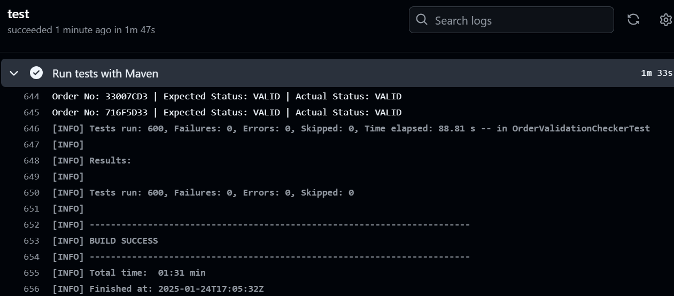
All tests passing after pushing to github

    - Successfully deploys builds for passing tests.
  - Provide logs and reports from CI runs to demonstrate functionality.

